Press Release 03 | 23

Topic | Product News
Headline | SPE connectors from ESCHA
Sub-headline | The future standard
Date | May 04, 2023
Characters (incl. blanks) | 1.398
Link for add‘l information | www.escha.net

Halver, May 04, 2023 - In comparison to current solutions with two or four twisted pairs of wires, Single Pair Ethernet (SPE) relies on only one twisted pair. This will result in a comparatively weight-saving infrastructure solution for IIoT and Industrie 4.0 applications in the future. SPE enables the simultaneous transmission of data and power up to the sensor level. Where previously it was necessary to switch to BUS protocols with the corresponding software and hardware, SPE now connects every sensor directly to higher-level Ethernet networks, closing the previous "Ethernet gap" above the field level. If required, in real time and with a noticeably increased range of functions. Complex parameterization of different systems is no longer necessary with the future-oriented Single Pair Ethernet technology.
As a completely new physical layer, SPE needs its own ecosystem of cables, connectors, semiconductors, passive components and active devices. ESCHA has also recognized this trend and developed overmoulded M8 and M12 connectors based on the T1 industrial interface specified in 2018 in accordance to IEC 63171-6, which meet the usual market sealing requirements (IP67) and are therefore particularly suitable for use in harsh industrial environments. This new product portfolio, which in the first step consists single and double ended cordsets (male-version), will be available at the beginning of 2024.

Photos | Caption
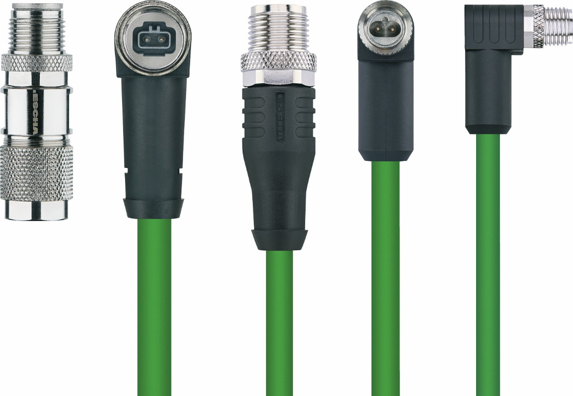

ESCHA PI0323: M8-, M12-Connectors

Source: ESCHA GmbH & Co. KG

About us

The ESCHA Group is a leading supplier in the field of industrial connectivity. For more than 35 years, the family-controlled company has been developing and manufacturing innovative product novelties taking dynamics to the market for automation components. Based on its standard products, the company designs custom-made connectivity and individual special solutions. With about 1000 employees around the globe and highly in-depth development and production, ESCHA is extending its product portfolio constantly and independently. The consolidated group turnover in 2022 amounts to 102 million Euros. ESCHA guarantees high availability and consistent quality of its products worldwide through production facilities in Germany, Czech Republic, Hungary and China as well as licensed production in USA and Mexico.

Reader Contact
ESCHA GmbH & Co. KG
Elberfelder Straße 32 | 58553 Halver | Germany

Phone: +49 2353 708-800
Fax: +49 2353 708-8410
Internet: www.escha.net
Email: info@escha.net

Media Contact
ESCHA GmbH & Co. KG
Dipl.-Design. Dominique Daniela Bicking
Marketing | Communication
Elberfelder Straße 32 | 58553 Halver | Germany

Phone: +49 2353 708-8156
Email: d.bicking@escha.net

