Press Release 04 | 23

Topic | Company News
Headline | ESCHA Group appoints further managing director
Sub-headline | Staying dynamic - ESCHA well positioned for the future.
Date | 19 July 2023
Characters (incl. blanks) | 1.151
Link for add‘l information | www.escha.net

Halver, 19 July 2023 – In times of rapidly changing market conditions and framework conditions, the ESCHA Group, headquartered in Halver, Westphalia, is repositioning itself by expanding its management team. With Dirk Aldermann, ESCHA appoints an experienced production and supply chain expert to the management board.

For many years already, Marco Heck and Dietrich Turck have been managing the business of the company group in Germany and abroad as managing directors of ESCHA.
Since July 3, 2023, Dirk Aldermann now strengthens the management team and is responsible for the departments production, supply chain and quality within the ESCHA Group.
With a degree in mechanical engineering and business administration, he has many years of experience as a manager in the industrial environment in the areas of production and materials management. Dirk Aldermann previously held executive positions as well as management responsibility at internationally operating companies.

Dietrich Turck is in charge of Finance and Human Resources as part of the new business allocation.
Marco Heck has been appointed CEO since July 2023 and is responsible for strategy, marketing and sales.

Photos | Caption
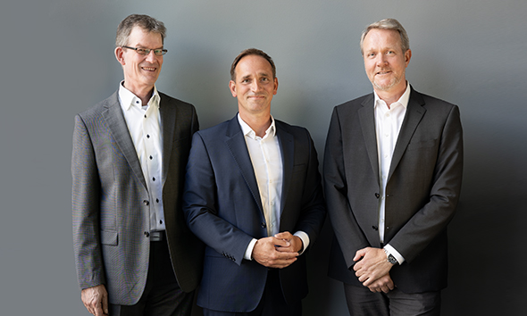
ESCHA PI0423: The Management Board of ESCHA GmbH & Co KG.
Dietrich Turck, Marco Heck, Dirk Aldermann ( f. l.)

Source: ESCHA GmbH & Co. KG

About us

The ESCHA Group is a leading supplier in the field of industrial connectivity. Since 40 years, the family-controlled company has been developing and manufacturing innovative product novelties taking dynamics to the market for automation components. Based on its standard products, the company designs custom-made connectivity and individual special solutions. With about 1000 employees around the globe and highly in-depth development and production, ESCHA is extending its product portfolio constantly and independently. The consolidated group turnover in 2022 amounts to 102 million Euros. ESCHA guarantees high availability and consistent quality of its products worldwide through production facilities in Germany, Czech Republic, Hungary and China as well as licensed production in USA and Mexico.

Reader Contact
ESCHA GmbH & Co. KG
Elberfelder Straße 32 | 58553 Halver | Germany

Phone: +49 2353 708-800
Fax: +49 2353 708-8410
Internet: www.escha.net
Email: info@escha.net

Media Contact
ESCHA GmbH & Co. KG
Dipl.-Design. Dominique Daniela Bicking
Marketing | Communication
Elberfelder Straße 32 | 58553 Halver | Germany

Phone: +49 2353 708-8156
Email: d.bicking@escha.net

