Press Release 01 | 23

Topic | Company News
Headline | New Director Sales EMEA ESCHA
Sub-headline | Michael Tölle takes overall sales responsibility
Date | 25 January 2023
Characters (incl. blanks)
Link for add‘l information | www.escha.net

Halver, 25 January 2023 – On 1 January 2023 Dipl.-Wirt.-Ing. Michael Tölle joined us as the new overall sales manager of ESCHA GmbH & Co. KG. After other sales-oriented management functions, most recently at Balluff GmbH, Michael Tölle is now assuming responsibility for sales EMEA at ESCHA.
At ESCHA, the 41-year-old is in charge of the Key-Account-Management, internal sales team and the sales activities of national and international distribution partners in the EMEA region.
In his new role, he reports directly to Managing Director Dipl.-Wirt.-Ing. Marco Heck.

“With Michael Tölle, we are gaining an experienced executive who is both familiar with our industry and customer applications, as well as bringing extensive international sales experience to the table, “ explains Marco Heck.

Internationalization and customer focus
"In addition to the innovative products, I was particularly convinced by the consistent focus on customers, the ongoing global orientation and the clear sales strategy of working with ESCHA," says Michael Tölle. "Together with the entire team, we will work on continuing the growth story of the past years."

Michael Tölle studied industrial engineering and also completed a Master of Arts in Corporate Management & Economics. Michael Tölle has already held national and international sales positions at Haver & Boecker, Eisenmann Anlagenbau and Balluff.
Photos | Caption

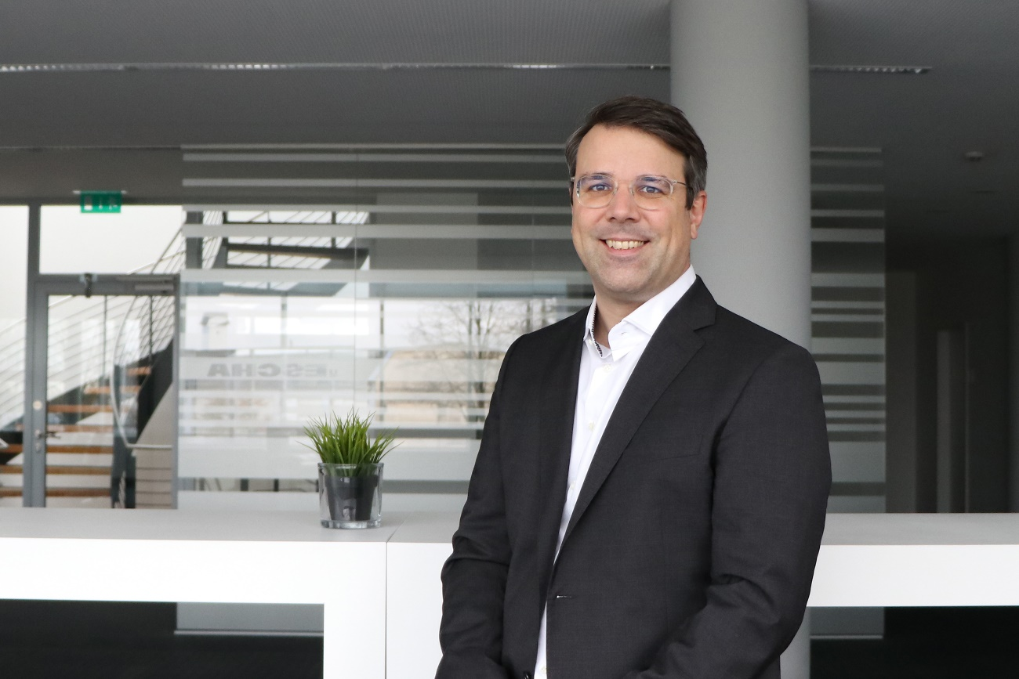
ESCHA PI0123_1: M.A., Dipl.-Wirt.-Ing. (FH) Michael Tölle is new Director Sales EMEA at
ESCHA GmbH & Co. KG.

Source: ESCHA GmbH & Co. KG

About us

The ESCHA Group is a leading supplier in the fields of connectivity and housing technology. For more than 35 years, the family-controlled company has been developing and manufacturing innovative product novelties taking dynamics to the market for automation components. Based on its standard products, the company designs custom-made connectivity and individual special solutions. With about 900 employees around the globe and highly in-depth development and production, ESCHA is extending its product portfolio constantly and independently. The consolidated group turnover in 2021 amounts to 87 million Euros. ESCHA guarantees high availability and consistent quality of its products worldwide through production facilities in Germany, Czech Republic and China as well as licensed production in USA and Mexico.

Reader Contact Germany Reader Contact Austria
ESCHA GmbH & Co. KG ESCHA GmbH & Co. KG
Elberfelder Straße 32 | 58553 Halver

Phone: +49 2353 708-800 Phone: +43 664 5451534
Fax: +49 2353 708-8410 Fax : +49 2353 708-8410
Internet: www.escha.net Internet : www.escha.net
Email: info@escha.net Email : info.austria@escha.net

Media Contact
ESCHA GmbH & Co. KG
Dipl.-Design. Dominique Daniela Bicking
Marketing | Communication
Elberfelder Straße 32 | 58553 Halver | Germany

Phone: +49 2353 708-8156
Email: d.bicking@escha.net

