Press Release 02 | 22

Topic | Company News
Headline | ESCHA and duotec establish attractive manufacturing capacities in the heart of Europe
Date | 2 March 2022
Characters (incl. blanks) | 2,489
Link for add‘l information | www.escha.net

Halver, 2 March 2022 – The ESCHA Group and duotec acquire highly qualified manufacturing capacities in Central Europe. duotec and ESCHA will jointly acquire 49 percent of the shares in SVI Hungary Kft on 1 March 2022, in Ajka (Western Hungary) by the SVI Group. Over the next two years, duotec and ESCHA will also take over the remaining 51 percent. Carsten Bremerskov, Vice President of Sales SVI Group: “The transaction is good news for SVI, duotec and the ESCHA Group as it will create new investments and business areas for SVI Hungary. I would like to congratulate our three groups on this successful transaction.”

Central location, short distances and 20 years of EMS competence

duotec and ESCHA will jointly increase production for SVI Hungary Kft. in the future and invest further. The first projects are already underway, as SVI Hungary Kft. with its approximately 120 highly qualified employees have a lot of experience, especially in the assembly of electrical and electronic components. From now on, duotec and ESCHA customers will be able to take advantage of further attractive benefits: diversified and stable supply chains with the highest quality. In addition, the entire transaction will be handled by the well-known duotec and ESCHA contact persons.

"In times of allocation and interrupted supply chains, access to regional production sites becomes more and more important. Therefore, we are pleased to welcome SVI Hungary, a competitive site to duotec," says Philipp Mirliauntas (CSO duotec).

"The ESCHA Group has experienced continuous growth in recent years. We are pleased that with the investment in SVI Hungary we have the opportunity to expand our production capacities in Europe and to continue the growth course we have embarked upon. Thanks to the excellently trained employees in Hungary, we will be able to continue to supply our customers reliably and with the usual high ESCHA quality," adds Dietrich Turck (Managing Director ESCHA Group).

Manufacturing in Central Europe

Following the acquisition of shares in the EMS service provider Tabemax S.J. in Poland at the end of last year by ml&s GmbH & Co. KG, a duotec company, another attractive manufacturing location is now available in Hungary. Bernd Odoj (COO duotec): "We are very much looking forward to the future cooperation with the Hungarian company. Together with SVI Hungary as an excellent producer, we will further develop the portfolio of the entire duotec and offer our customers an optimal and sustainable product range."

Photos | Caption

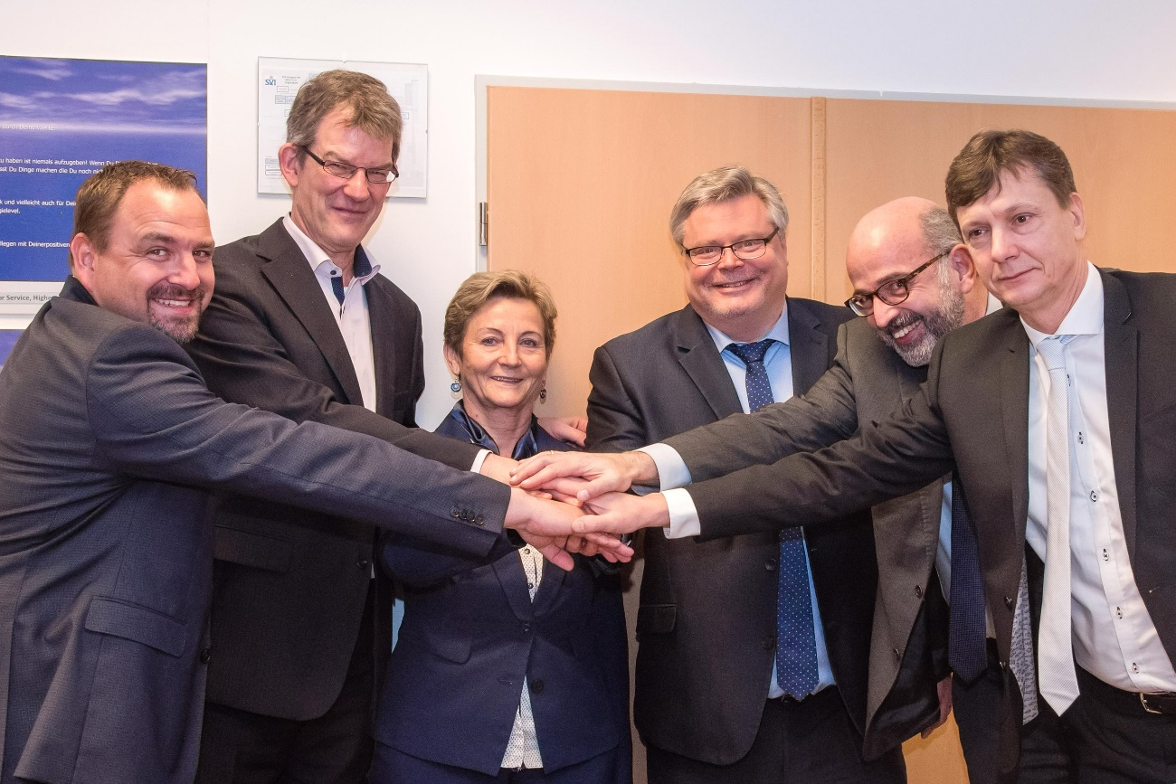
ESCHA PI0222_1: Contract signing in Ajka, Hungary: Gerold Grill, Managing Director SVI Austria; Dietrich Turck, Managing Director ESCHA; Gizella Zelity, Managing Director SVI Hungary; Bernd Odoj, COO duotec; Phlipp Mirliauntas, CSO duotec; Carsten Bremerskov, Vice President of Sales SVI Group (left to right).

Source: ESCHA GmbH & Co. KG

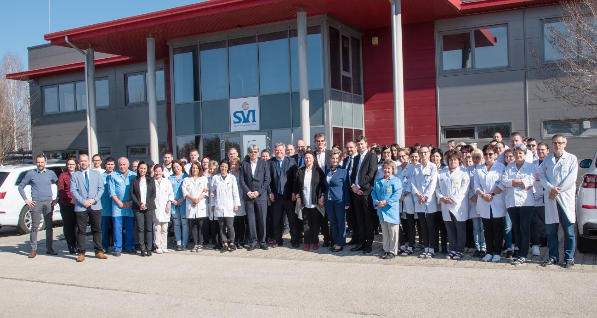
ESCHA PI0222_2: The employees of SVI Hungary Kft. are pleased about the investment of ESCHA and duotec.

Source: ESCHA GmbH & Co. KG

About us
ESCHA PI0222_3: Headquarters of the ESCHA Group in Halver, Germany.

Source: ESCHA GmbH & Co. KG

ESCHA – specialist in connectivity.

The ESCHA Group is a leading supplier in the field of industrial connectivity. For more than 35 years, the family-controlled company has been developing and manufacturing innovative product novelties taking dynamics to the market for automation components. Based on its standard products, the company designs custom-made connectivity and individual special solutions. With about 840 employees around the globe and highly in-depth development and production, ESCHA is extending its product portfolio constantly and independently. The consolidated group turnover in 2021 amounts to 87 million Euros. ESCHA guarantees high availability and consistent quality of its products worldwide through production facilities in Germany, Czech Republic, Hungary and China as well as licensed production in USA and Mexico.

duotec Ahead of innovation.

duotec is a global electronics service provider for innovative microelectronics, EMS, EMS+, E2MS (Electronics Engineering and Manufacturing Services), sensor and connectivity solutions, ODM (Original Design Manufacturing) as well as disruptive innovations such as quantum technology, e-nose and smart textiles. More than 1000 employees work at the sites in Halver, Grünhain-Beierfeld, Berlin, Delémont (CH) and Arteaga (MX). The companies involved also include ml&s manufacturing logistics & services GmbH & Co. KG Greifswald and manufacturing partner Tabemax S.J. in Poland. The companies are certified according to ISO 9001, EN ISO 13485, IATF16949, ISO 27001 and ISO/IEC 17025, among others. duotec develops specific electronic solutions for automotive, railroad, energy, building automation, industry, medical technology, mobility, telecommunications and IT.

Reader Contact
ESCHA GmbH & Co. KG
Elberfelder Straße 32 | 58553 Halver/Germany

Phone: +49 2353 708-800
Fax: +49 2353 708-8410
Internet: www.escha.net
Email: info@escha.net

Media Contact
ESCHA GmbH & Co. KG
Florian Schnell
Director Marketing
Elberfelder Straße 32 | 58553 Halver/Germany

Phone: +49 2353 708-8156
Mobile: +49 151 14192185
Email: f.schnell@escha.net

