Press Release 07 | 22

Topic | Product News
Headline | Product Premieres at SPS 2022
Sub-headline | ESCHA shows novelties
Date | 21 September 2022
Characters (incl. blanks) | 4.382
Link for add‘l information | www.escha.net

Halver, 21 September 2022 – At the SPS 2022 in Nuremberg, the German connectivity specialist ESCHA is giving an outlook on the coming trends and technologies that will shape the development of connectors in the coming years. The main focus will be on Single Pair Ethernet technology (SPE). ESCHA will show over molded M8- and M12-connectors based on the T1 industrial interface according to IEC 63171-6. In addition, the company is showing two novelties that will extend already existing product portfolios. On the one hand, these include new Deutsch-DT-connectors in additional polarities and in LED-variants, which are primarily aimed at applications in the field of mobile automation. On the other hand, new shielded connectors that complement the present multipole M8 product range.

Single Pair Ethernet – The future standard

Single Pair Ethernet (SPE) is the future technology in industrial automation. Using compact cables and connectors, high data transmission rates can be brought to the most distant sensor in the field. SPE is a vital component on the way to a fully networked production as envisaged in Industry 4.0 or IIoT. Based on the T1 industrial interface according to IEC 63171-6, which was defined in 2018, ESCHA has developed over molded M8- and M12-connectors, which meet the market-based tightness requirements and therefore are particularly suitable for use in harsh industrial environments. They will be available as single-ended- and double-ended cord sets and facilitate the power transmission typical for SPE (Power over Data Line).

Connectors in Deutsch-DT design for mobile automation

In the agricultural sector and commercial vehicle industry, exceptionally high demands are placed on connectivity. The environmental conditions and everyday stresses are extreme. In this sector, as well, the trend is away from manual assembly and towards over molded connectivity that can be used immediately. The advantages are obvious: less susceptibility to errors as well as faster, more reliable and more cost-effective wiring. ESCHA has developed a product range with over molded connectors based on the widely used Deutsch-DT design, which combines the aforementioned advantages in one product. Additionally, it does not fall back on prefabricated components, but offers a solution engineered from scratch at ESCHA, in which the self-designed contacts and contact carriers are over molded in a one-shot process. This avoids long supply chains and ensures high availability. So far, 2-, 4- and 6-pole versions are available in male- and female design as well as single-ended- and double-ended cord sets. The new 3-, 8- and 12-pole versions and LED variants will be shown at SPS.

As usual at ESCHA and upon customer request, different modification options are possible, such as double-ended cord sets with M12-connectors on the B-side. Due to this wide range of variants, the over molded connectors in Deutsch-DT design do not only replace the field-wireable variants that were primarily used up to now, they also offer a compact alternative to valve connectors. The DT-connectors can optionally be equipped with a threaded grip body for protective hoses. The protective hoses offer additional protection against stone chips and pollution in the outdoor area. All products meet the high demands of protection class IP67, IP68 and IP69.

Multipole M8-connectivity in shielded design

Sensors are becoming more compact and more complex; therefore, they have to deliver even more information, too. Due to this development, the demand for simultaneously compact and multipole connectors is rising. The connectivity specialist ESCHA meets this demand with its M8-product-range in 8-pole-design. So far, the ESCHA multipole product range only consisted of unshielded versions. The shielded versions will celebrate their premiere at the SPS. At market launch, straight and angled versions will be available in male and female design, which – in combination with the «S370» (PUR/PP) cable quality – have UL-approval. With the cable quality «P00» (PVC/PVC) there is also a cost-effective alternative to choose from.

Standard, Special, Tailor-made

In addition, ESCHA is again showing solutions out of its comprehensive standard portfolio as well as interesting modification projects and customer-specific developments. Visitors can get information on these topics on Stand 321 in Hall 10.0 from 8 to 10 November.

Photos | Caption

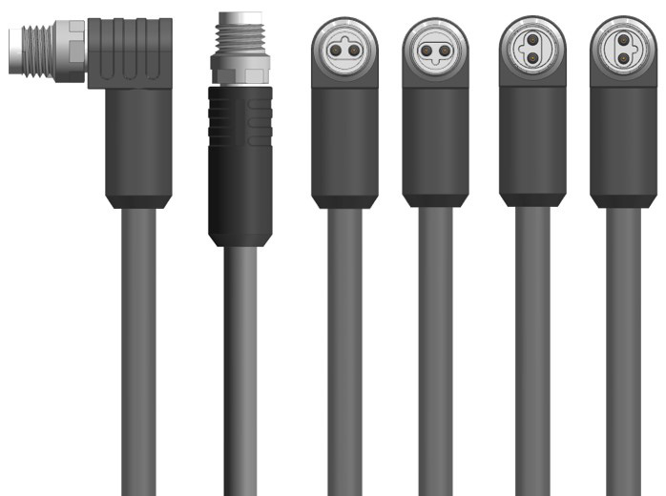
ESCHA PI0722_1: The new ESCHA SPE-connectors in M8 design.

Source: ESCHA GmbH & Co. KG

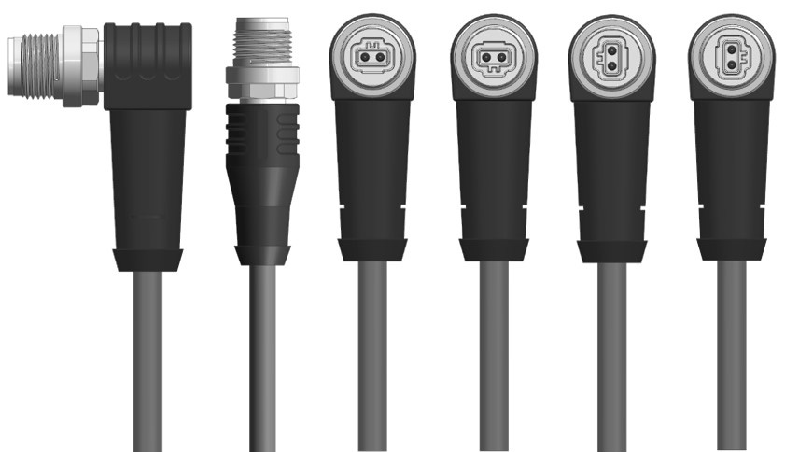
ESCHA PI0722_2: The new ESCHA SPE-connectors in M12 design.

Source: ESCHA GmbH & Co. KG
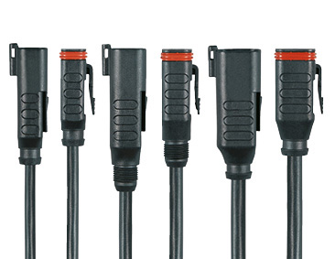
ESCHA PI0722_3: Deutsch-DT-connectors from ESCHA will be supplemented by 3-, 8- and 12-pole versions.

Source: ESCHA GmbH & Co. KG

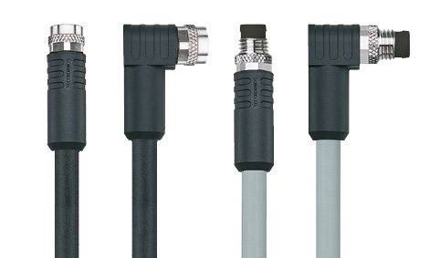
About us
ESCHA PI0722_4: ESCHA extends its 8-pole M8-portfolio by shielded variants in straight and angled housing style in male and female design.

Source: ESCHA GmbH & Co. KG

The ESCHA Group is a leading supplier in the field of industrial connectivity. For more than 35 years, the family-controlled company has been developing and manufacturing innovative product novelties taking dynamics to the market for automation components. Based on its standard products, the company designs custom-made connectivity and individual special solutions. With about 840 employees around the globe and highly in-depth development and production, ESCHA is extending its product portfolio constantly and independently. The consolidated group turnover in 2021 amounts to 87 million Euros. ESCHA guarantees high availability and consistent quality of its products worldwide through production facilities in Germany, Czech Republic, Hungary and China as well as licensed production in USA and Mexico.

Reader Contact
ESCHA GmbH & Co. KG
Elberfelder Straße 32 | 58553 Halver

Phone: +49 2353 708-800
Fax: +49 2353 708-8410
Internet: www.escha.net
Email: info@escha.net

Media Contact
ESCHA GmbH & Co. KG
Florian Schnell
Director Marketing
Elberfelder Straße 32 | 58553 Halver/Germany

Phone: +49 2353 708-8156
Mobile: +49 151 14192185
Email: f.schnell@escha.net

