Press Release 06 | 22

Topic | Product News
Headline | Connectivity for the food processing industry
Sub-headline | Complete portfolio in Hygienic Design
Date | 13 July 2022
Characters (incl. blanks) | 2,688
Link for add‘l information | www.escha.net/en/products/industries/food-und-beverage

Halver, 13 July 2022 – The food processing industry sets high demands in terms of hygiene and process security that by far exceed those of the classical machinery. These demands can be transferred on-to-one to connectors and cables. The German connectivity specialist ESCHA offers a broad product range in so-called «Hygienic Design» that can be used without any concerns in this demanding application area due to specifically selected plastics and cable qualities as well as highest protection classes (IP67, IP68 and IP69). ESCHA has set up a portfolio that includes connectivity solutions for the three typical zones within the food- and beverage industry: Contact zone, spray zone and packaging zone.

Contact zone

In the contact zone, food can get in contact with system parts and afterwards be returned to the handling process. Therefore, the hygiene requirements are particularly high in this area. To avoid the deposit of residues, connectors may not contain any dirt pockets. That is why ESCHA has developed a product range of M8- and M12-connectors in Hygienic Design, referring to EHEDG directives (European Hygienic Engineering & Design Group). Moreover, FDA compliant materials and a high-quality TPE cable quality guarantee a high resistance to sour and alkaline cleaning- and disinfectant agents. All sealing- and optical properties of the connectors are maintained in the long run despite regular use of steam-jet- and high-pressure cleaning.

Spray zone

In the spray zone – also called wash-down zone – food may also enter in contact with system parts, but will not be returned to the handling process. Thus, the hygiene requirements towards connectors and cables are correspondingly lower in this zone. ESCHA offers easy to clean M8- and M12-connectors in Hygienic Design, which are equipped with a PVC cable quality adapted to the spray zone. The M12-connectors are also optionally available with high-quality plastic locking nuts, which offer a cost-effective alternative to the usual V4A stainless steel.

Packaging zone

In contrast to the contact zone and the spray zone, the packaging zone is comparable to the classic industrial area. The food can no longer get in contact with system parts there. Therefore, aggressive cleaning agents and steam-jet cleaning are not required. For this zone, ESCHA has set up a multi-variant product range, which uses products from the proven sensor-/actuator wiring. This means that the entire range of different standard cable qualities is available. From the all-rounder «S370» to robotic cables to particularly flexible cables that easily withstand several million torsion- and bending cycles and are therefore predestined for use in drag-chain applications.

Photos | Caption

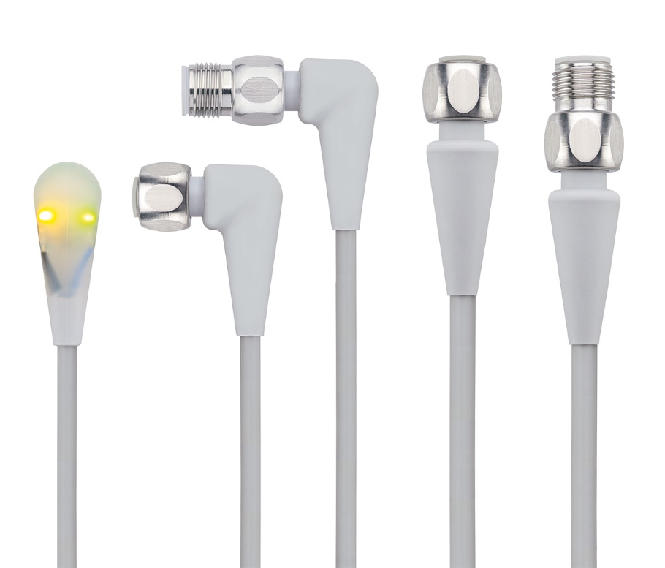
ESCHA PI0622_1: Food & Beverage connectors from ESCHA in Hygienic Design meet the extremely high demands in the food processing industry.

Source: ESCHA GmbH & Co. KG

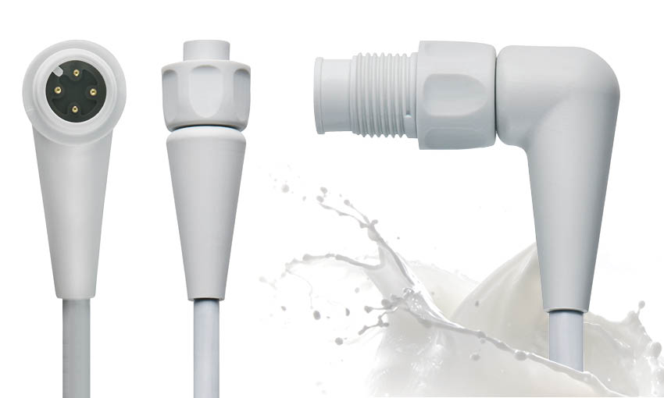
ESCHA PI0622_2: Variants with plastic locking-nuts offer the same level of security, but do not use V4A stainless steel and therefore offer a cost-effective alternative.

Source: ESCHA GmbH & Co. KG

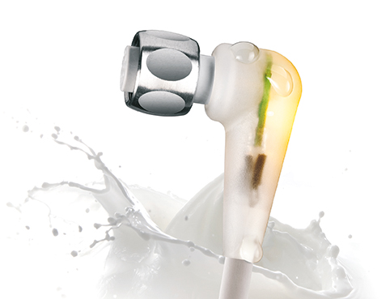
ESCHA PI0622_3: ESCHA also offers LED variants that are particularly suitable for installation situations in which – for example – the sensor status display is not recognizable at first glance.

Quelle: ESCHA GmbH & Co. KG

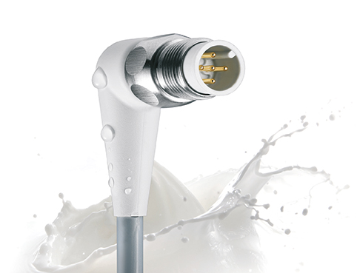
About us
ESCHA PI0622_4: Connectors in Hygienic Design from ESCHA can safely get into contact with food. They are easy to clean and withstand detergent- and disinfectant agents.

Quelle: ESCHA GmbH & Co. KG

The ESCHA Group is a leading supplier in the field of industrial connectivity. For more than 35 years, the family-controlled company has been developing and manufacturing innovative product novelties taking dynamics to the market for automation components. Based on its standard products, the company designs custom-made connectivity and individual special solutions. With about 840 employees around the globe and highly in-depth development and production, ESCHA is extending its product portfolio constantly and independently. The consolidated group turnover in 2021 amounts to 87 million Euros. ESCHA guarantees high availability and consistent quality of its products worldwide through production facilities in Germany, Czech Republic, Hungary and China as well as licensed production in USA and Mexico.

Reader Contact
ESCHA GmbH & Co. KG
Elberfelder Straße 32 | 58553 Halver/Germany

Phone: +49 2353 708-800
Fax: +49 2353 708-8410
Internet: www.escha.net
Email: info@escha.net

Media Contact
ESCHA GmbH & Co. KG
Florian Schnell
Director Marketing
Elberfelder Straße 32 | 58553 Halver/Germany

Phone: +49 2353 708-8156
Mobile: +49 151 14192185
Email: f.schnell@escha.net

