Press Release 03 | 22

Topic | Product News
Headline | Individual cable harnesses from ESCHA
Sub-headline | Complex wiring easily realized
Date | 8 March 2022
Characters (incl. blanks) | 1,502
Link for add‘l information | www.escha.net

Halver, 8 March 2022– The connectivity specialist ESCHA does not only offer unique single-ended- and double-ended cord sets, it also offers manufactured cable harnesses adapted to individual customer requirements. Complex wiring structures can easily be realized with these harnesses. Overmolded connectors from ESCHA can be combined into inch-perfect cable harnesses facilitating and speeding up fitters’ work. It is possible to label cables through a variety of markings and printings simplifying allocation of cables and contributing to reducing installation time as well.

Meanwhile, single cord sets are no more used in many applications, but readily made harnesses. Typical examples of this are wind turbines or the railway industry. ESCHA manufacturers cable harnesses for wind turbines with a total length of over 18 meters. In the railway industry, the variability is very high because individual cable harnesses are often required due to the different specifications for individual wagons. Cable harnesses have many advantages over single cables: They need small space and can be installed more easily and quickly.

Individualization upon customer request

Upon customer request, ESCHA equips overmolded connectors in cable harnesses with markings, printings and protective hoses facilitating installation even by unskilled staff. In order to make sure cable harnesses can be directly installed, they undergo a hundred percent electrical test at ESCHA. On demand, they are packed and shipped as customer individual sets.

Photos | Caption

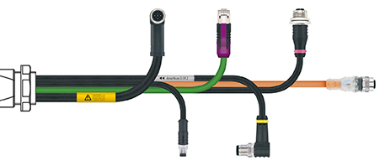
ESCHA PI0322: ESCHA offers manufactured cable harnesses adapted to individual customer requirements.

Source: ESCHA GmbH & Co. KG

About us

The ESCHA Group is a leading supplier in the field of industrial connectivity. For more than 35 years, the family-controlled company has been developing and manufacturing innovative product novelties taking dynamics to the market for automation components. Based on its standard products, the company designs custom-made connectivity and individual special solutions. With about 840 employees around the globe and highly in-depth development and production, ESCHA is extending its product portfolio constantly and independently. The consolidated group turnover in 2021 amounts to 87 million Euros. ESCHA guarantees high availability and consistent quality of its products worldwide through production facilities in Germany, Czech Republic, Hungary and China as well as licensed production in USA and Mexico.

Reader Contact
ESCHA GmbH & Co. KG
Elberfelder Straße 32 | 58553 Halver/Germany

Phone: +49 2353 708-800
Fax: +49 2353 708-8410
Internet: www.escha.net
Email: info@escha.net

Media Contact
ESCHA GmbH & Co. KG
Florian Schnell
Director Marketing
Elberfelder Straße 32 | 58553 Halver/Germany

Phone: +49 2353 708-8156
Mobile: +49 151 14192185
Email: f.schnell@escha.net

