Press Release 04 | 22

Topic | Product News
Headline | Overmolded connectors in Deutsch-DT design
Sub-headline | ESCHA introduces comprehensive portfolio
Date | 22 March 2022
Characters (incl. blanks) | 3,560
Link for add‘l information | www.escha.net

Halver, 22 March 2022 – The connectivity specialist ESCHA has developed a new and comprehensive product portfolio with overmolded connectors in Deutsch-DT design. The rectangular connectors are particularly suitable for application areas in the field of agricultural- and construction machinery, emergency vehicles as well as the transport industry and the extreme environmental conditions and loads prevailing there. The new product range is available with immediate effect and is already available for market launch in the typical 2-, 4- and 6-pole versions in male- and female design. In combination with the ESCHA exclusive PUR cable called «S370», the new connectors in Deutsch-DT design become real all-rounders.

The agricultural sector and commercial vehicle industry set exceptionally high demands in terms of connectivity. The environmental conditions and every-day loads are particularly challenging. Even in this industry, the trend is moving away from manual assembly to overmolded and immediately usable connectivity. The advantages of this solution are obvious: A reduced error rate as well as a faster, more reliable and more cost-effective wiring. The new product range in Deutsch-DT design from ESCHA combines the aforementioned advantages in one product. Additionally, it does not fall back on field-wireable components –as usual in the market. It offers a one-shot-solution engineered from scratch at ESCHA. This avoids long supply chains and ensures high availability.

High variety

At the market launch, the product range will include single-ended cord sets with open cable ends as well as double-ended cord sets with overmolded connectors in Deutsch-DT design on the B-side. As usual at ESCHA and upon customer request, different modification options are possible, such as double-ended cord sets with M12-connectors on the B-side. Due to this wide range of variants, the overmolded connectors in Deutsch-DT design not only replace the field-wireable variants that were primarily used up to now, they also offer a compact alternative to valve connectors.

The DT-connectors can optionally be equipped with a threaded grip body for protective hoses. The protective hoses offer additional protection against stone chips and pollution in the outdoor area. All products meet the high demands of protection classes IP67, IP68 and IP69. The molded release tab prevents unintentional disconnection under load and increases safety. An also molded dovetail can be used for installation. To increase clarity in the application, colored marking rings can be ordered as matching original accessories.

Complete program for «Mobile Automation»

Next to the new connectors in Deutsch-DT design, ESCHA has been offering M12-connectors with plastic locking nuts for a while. These are also particularly suitable for demanding applications in the agricultural- and commercial vehicle sector. Due to their robustness, they offer a cost-effective alternative to stainless-steel locking nuts. The high-quality plastics do not only withstand extreme temperature changes from -30°C to +90°C, furthermore, they consist of UV stabilizers prevent them getting porous or rough. In addition, they can be easily removed from containments with pressurised water, mud or oil. Through their unique design, the plastic locking nuts can be tightened by hand as well as with a torque wrench. Afterwards, they also fulfil the high protection degrees according to IP67, IP68 and IP69. The plastic locking nuts are available in black, grey, red or blue to easily mark, match and differentiate the connectors.

Photos | Caption

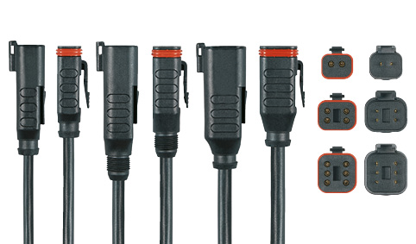
ESCHA PI0422: The new ESCHA connectors in Deutsch-DT design are available in 2-, 4- and 6-pole versions.

Source: ESCHA GmbH & Co. KG

About us

The ESCHA Group is a leading supplier in the field of industrial connectivity. For more than 35 years, the family-controlled company has been developing and manufacturing innovative product novelties taking dynamics to the market for automation components. Based on its standard products, the company designs custom-made connectivity and individual special solutions. With about 840 employees around the globe and highly in-depth development and production, ESCHA is extending its product portfolio constantly and independently. The consolidated group turnover in 2021 amounts to 87 million Euros. ESCHA guarantees high availability and consistent quality of its products worldwide through production facilities in Germany, Czech Republic, Hungary and China as well as licensed production in USA and Mexico.

Reader Contact
ESCHA GmbH & Co. KG
Elberfelder Straße 32 | 58553 Halver

Phone: +49 2353 708-800
Fax: +49 2353 708-8410
Internet: www.escha.net
Email: info@escha.net

Media Contact
ESCHA GmbH & Co. KG
Florian Schnell
Director Marketing
Elberfelder Straße 32 | 58553 Halver/Germany

Phone: +49 2353 708-8156
Mobile: +49 151 14192185
Email: f.schnell@escha.net

