Press Release 01 | 25

Topic | Product News
Headline | ESCHA expands the ET series: New ETM connector for extreme conditions
Sub-headline | Space-Saving, Durable, Reliable
Date | April 2, 2025
Character (incl. blancs) | 3.287
Link for add’l information | escha.net

Halver, April 2, 2025 – ESCHA presents the new ETM connector, a compact and durable addition to the proven ET series. Developed for demanding applications in mobile automation, the 2-pin connector offers reliable signal and power transmission even under extreme conditions. Its plug-compatible alternative to DTM/ATM connectors allows for easy integration into existing systems and ensures a future-proof wiring solution.

Compact, durable, powerful
Connectors in mobile machines must withstand extreme stress. In construction machinery, agricultural technology, commercial vehicles, or autonomous transport systems, they are exposed to dust, moisture, vibrations, and strong temperature fluctuations on a daily basis. At the same time, modern vehicles increasingly require more compact installation solutions without compromising on safety and performance.

This is where the ETM connector comes in. Its robust design is specially optimized for tight installation spaces and high mechanical loads. The ETM is characterized by high resistance to dust, water, dirt, and extreme temperatures.

Maximum reliability with IP69K protection
With an IP69K rating, the ETM connector is dustproof and waterproof, making it ideal for off-highway vehicles and mobile machinery. Its vibration-resistant construction ensures a reliable connection even under strong shock loads. This is especially crucial in industries such as agricultural technology and construction, where machinery must operate under harsh conditions.

Another highlight is the innovative manufacturing process with One-Shot technology. This highly precise method enables production in a single step. As a result, dependencies on external suppliers are minimized, production processes are optimized, and product availability is increased. This allows ESCHA to respond flexibly to market demands and ensure consistently high quality.

Key advantages at a glance
- Plug-compatible with DTM/ATM – easy retrofit and integration.
- Compact design – ideal for confined installation conditions.
- High vibration resistance – stable connection even under strong shocks.
- IP69K protection class – dustproof and waterproof for demanding applications.
- Optimized availability – through innovative One-Shot manufacturing technology.

Future-proof technology for mobile applications
With the introduction of the ETM connector, ESCHA expands its portfolio and offers even more flexibility for the increasing demands of mobile automation. The combination of ET and ETM allows for optimal adaptation to various installation conditions and ensures maximum operational reliability. Its wide applicability makes the ETM an attractive choice for companies that rely on durable and high-performance components.

Especially in autonomous vehicles and modern transport solutions, robust connectors play a crucial role. The ETM is not only a solution for existing mobile machines but also an ideal choice for the growing requirements of automation technology.

ESCHA’s ETM stands for maximum flexibility, durability, and performance – qualities that are essential today and in the future. Thanks to its compact design and high-quality craftsmanship, the ETM provides a long-term solution for industrial applications and contributes to increased efficiency in mobile automation.

Photos | Caption
Photo 1:
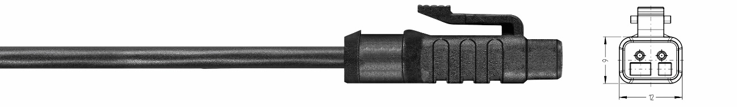
ESCHA PI0125: ESCHA ETM Connector Source: ESCHA GmbH & Co. KG

Photo 2:


ESCHA PI0125: ETM: Maximum performance in the smallest space Source: ESCHA GmbH & Co. KG

Photo 3:
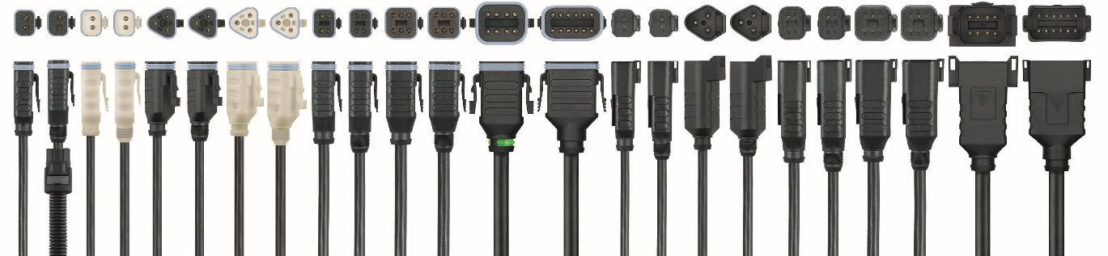
ESCHA PI0125: ESCHA ET-Family Source: ESCHA GmbH & Co. KG

About us

The ESCHA Group is a leading supplier in the field of industrial connectivity. For more than 35 years, the family-controlled company has been developing and manufacturing innovative product novelties taking dynamics to the market for automation components. Based on its standard products, the company designs custom-made connectivity and individual special solutions. With about 1000 employees around the globe and highly in-depth development and production, ESCHA is extending its product portfolio constantly and independently. The consolidated group turnover in 2022 amounts to 102 million Euros. ESCHA guarantees high availability and consistent quality of its products worldwide through production facilities in Germany, Czech Republic, Hungary and China as well as licensed production in USA and Mexico.

Reader Contact
ESCHA GmbH & Co. KG
Elberfelder Straße 32 | 58553 Halver | Germany

Phone: +49 2353 708-800
Fax: +49 2353 708-8410
Internet: www.escha.net
Email: info@escha.net

Media Contact
ESCHA GmbH & Co. KG
Alexander Gaubatz
Head of Product Management
Elberfelder Straße 32 | 58553 Halver | Germany

Phone: +49 2353 708-8159
Email: a.gaubatz@escha.net

